CHAPTER 3: MATERIAL AND METHODOLOGY
3.1: INTRODUCTION
The development of the e-commerce website for Johnson’s fashion hub will follow a structured and iterative approach to ensure the delivery of a high-quality, user friendly, and scalable platform. This section outlines the methodologies, tools, and technologies that will be employed throughout the project lifecycle. The process will be divided into key phases including planning, design, development, testing, and deployment, each tailored to meet the specific requirements of Johnson’s fashion hub.
To achieve the project objectives, a combination of industry-standard practices and cutting-edge technologies will be utilized. The website will be built on a robust e-commerce platform, ensuring seamless functionality, security, and scalability. The design will focus on creating an engaging and intuitive user interface (UI) that aligns with the brand’s identity, while the development phase will prioritize responsive design, fast loading times, and integration with essential third-party services.
The methodologies adopted for this project include Agile development for flexibility and iterative progress, user-centered design (UCD) to ensure the website meets the needs of the target audience, and quality assurance (QA) practices to deliver a bug-free and reliable platform. Below, we detail the specific materials, tools, and methods that will be used to bring Johnson’s fashion hub’s e-commerce vision to life.
3.2: SOFTWARE CYCLE MODEL
The Agile model is an iterative and incremental approach to software development that emphasizes collaboration, customer feedback, and small, rapid releases. It is well-suited for the Johnson’s fashion hub e-commerce website project as it allows for continuous improvement and ensures that the final product aligns with the client’s evolving needs. Below are the key stages involved in the Agile model that we used:
- Planning
Objective: We defined the project scope, goals, and requirements.
Activities:
- We conducted meetings with stakeholders to gather requirements.
- We prioritize features based on business needs.
- We created a product backlog (a list of tasks and features).
- We define sprint goals and timelines.
- Design
Objective: To create wireframes, mockups, and prototypes for the website.
Activities:
- Developed user personas and user stories.
- Designed the user interface (UI) and user experience (UX).
- Created responsive layouts for desktop, tablet, and mobile devices.
- Reviewed and refined designs with stakeholders.
- Development
Objective: To build the website’s core features and functionalities.
Activities:
- We broke down tasks into smaller sprints
- We developed and integrate front-end components.
- Implemented Johnson’s fashion hub functionalities (product catalog, shopping cart, checkout).
- We integrated third-party services (payments gateways, shipping providers and others).
- Testing
Objective: To ensure the website is bug-free, functional, and user-friendly.
Activities:
- We performed unit testing, integration testing, and system testing.
- We conducted user acceptance testing (UAT) with stakeholders.
- We identified and fixed bugs or issues.
- We optimized website performance based on speed, responsiveness, and other properties.
- Deployment
Objective: To launch the website for public use.
Activities:
- Addressing user feedback and fix any bugs.
- Implementation new features or improvements.
- Perform regular updates and security patches.
We choose Agile model since it is flexible, customer-centric, faster delivery and promotes collaboration between developers, designers, and stakeholders.
3.3: FEASIBILITY STUDY
The development of the Johnson’s Fashion Hub is feasible from technical, economic, operational, scheduling, and legal perspectives. The project aligns with the business goals, leverages available technologies, and offers a strong potential for growth and profitability. With proper planning and execution, the fashion website will provide a robust platform for Johnson’s fashion hub to expand its online presence and increase sales.
3.4: REQUIREMENTS, ANAYSIS, AND SPECIFICATIONS
3.4.1: FUNCTIONAL REQUIREMENTS
- User management- users can register, log in, and manage their profiles.
- Product management- products should include details like name, description, and prize.
- Shopping cart- users can add/remove products to/from the cart.
- Checkout and payment- users can proceed to checkout as guests or logged-in users.
- Order management- Admin can manage orders.
- Responsive design- The website should be fully optimized for desktop, tablet, and mobile devices.
3.4.2: NON-FUNCTIONAL REQUIREMENTS
- Performance- The website should load within 3 seconds.
- Security- Regular security updates and vulnerability testing.
- Scalability- The website is scale to accommodate future growth in traffic and products.
- Usability- intuitive and user-friendly interface for both customers and admins.
ANALYSIS
The analysis phase involves understanding the needs of the business and its target audience, as well as identifying potential challenges and opportunities.
- Business needs: provide a platform to sell products online and reach a wider audience.
- User needs: users should be able to browse and purchase products easily.
- Challenges: Regular updates and maintenance to ensure optimal performance and security.
SPECIFICATIONS
Based on the requirements and analysis the specifications below are applicable:
- Homepage: Hero banner with featured products.
- Product pages: High quality images with zoom functionality, product descriptions, pricing, and customer reviews.
- Checkout process: Multiple payments gateways (physical and online).
- Layout: clean and minimalistic with a focus on product visuals.

3.5: SYSTEM DESIGN
We used data flow diagram for the system design.
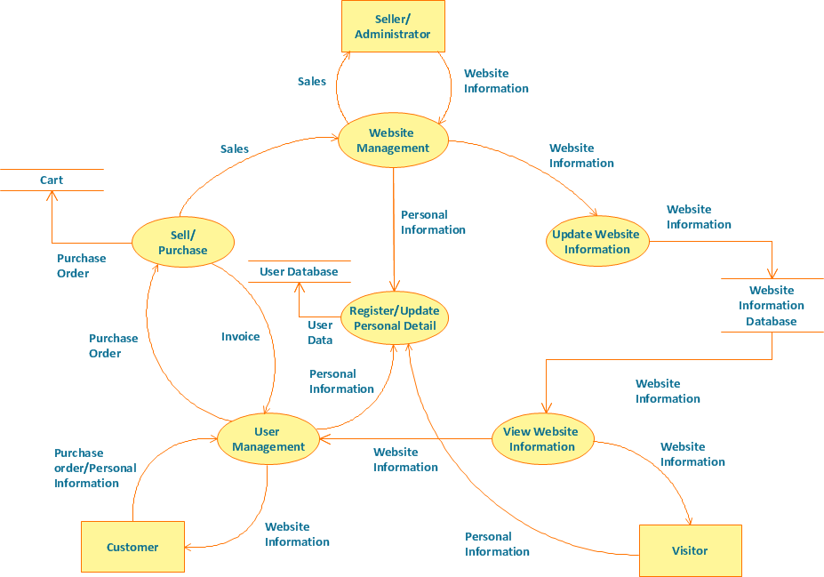

3.7: INPUT AND OUTPUT DESIGN
In the website we have the form container for entering users’ information, this is applicable in a sense that the admin will know the age of the customer and whether he or she is eligible to pay online or by physical mode.
We also have the login and sign up login form for ensuring the system keeps track of the preferences and taste of recipient by syncing data from the previous logins.
3.8: IMPLEMENTATION
We used HTML, JAVASCRIPT, AND CSS for styling the pages. The languages are important and effective since they provide the response we want throughout our project. The languages enabled us to use slider in the cart section and also to set a dynamic upgrade for the cart through JAVASCRIPT local storage technique.
3.9: INTEGRATION AND SYSTEM TESTING
By following a structured testing approach and leveraging the right tools and methodologies, we will deliver a high-quality, secure, and reliable platform that meets the business requirements and provides an exceptional user experience.
Tools used were Jira and TestRail for compatibility throughout all devices and browsers.

